**SALTO NEWS**

I have now been in position as Technical Director for 3 years now. To say that the time has flown by, is and understatement. When I first took on the role I had this wonderful delusion that once I had organised everything I had set in my mind to do, that the Gym would run like a well oiled engine. I have to say that it is just as well that I never set any time frames. I have found that Salto Gymnastics club is an evolvement. I have come to accept that it will keep on growing. There is always something else to do! Something else to take on that will keep us moving towards running the Best Gymnastics Club in Bedfordshire.

**Contents**

Salto News …………………………. 1

General Gym Grouping Together for success ............................ 2

Salto 200 Club ..........................3

Bedfordshire County Floor and Vault ...................................... 4

Relax, stretch and breathe ...... 5

Acrobatic Gymnastics ............. 6

Tumbling Report ......................7

Salto Contact List ………………….. 8

Salto Summer School ...............9

**Play Gym Parental Sessions**

Tuesday, Wednesday, Thursday and Friday, 4:30 till 7pm.

Available for siblings of gymnasts who are in lessons. £1 an hour.

Trampolining and General Gymnastics sessions available please contact the office.

I have always stopped to wonder at the Calibre of coaches we have managed to attract and who stay at the Club long term. The willingness of the older gymnasts to become Coaches and volunteer their wealth of knowledge of practical and sometimes painful experience.

Of course we see many gymnasts come and go particularly at recreational level but many just hang on into the end.

I recently attended a regional meeting where I listened to some of the Elite Clubs voicing their concerns as to how they were unable to keep Gymnasts passed the age of 12. They wanted to know what they should do to encourage youngsters to stay in the sport. It occurred to me to ask them to come and see Salto in action. In one of our competing squads we will see one of our gymnasts shortly see her 18th birthday! And in another both Mother and daughter compete!

Of course I am totally prejudiced when I say how great we are at Salto but you know I think there are a few people out there that would agree.

Well maybe not so if the question had been asked on the morning of the 20th June when they woke up (well those that got some sleep any way!) on the morning after the Salto Summer fun day and sleepover. The idea came to me in one of those Mad moments and was voiced before I had time to think it through. So there I was faced with the task of organising a Fun day with an Evening BBQ disco and sleepover. Well I did and we raised a massive £1145.00 which will pay for a new set of Portable Assymetric Bars. I would like to say a big and personal thank you to everyone that helped out in the run up and on the day itself. Particular thanks to those that did



the sleepover and the two Nigels for their BBQ skills. Well Done everyone.

Helen Matthews

Technical Director

**General Gym Grouping Together for Success**

Salto Gymnastics Club were privelged to host the New Level 3 Eastern Counties General gymnastics Championships. On the 16th May along with 2 other clubs our gymnasts performed on seven different apparatus and a Group floor routine. The new style competition designed to offer more skills than ever before was a huge success. The pinnacle of the success being the group floor performed by the General Gym squad taking Gold. Followed by the 2nd team from Salto made up of the younger artistic girls .

Individual performances of the day had to go to Under 11’s Brooke Mcaurther who took 4 golds and 2 silvers, followed closely by Faye Leek. In a younger age group Emma Sheehan took on the Elite girls to achieve 2 Gold 2 Silver and 2 bronze.

The elite girls saw Kesia Sawdon to a victory taking 4 Gold 2 Silver and a Bronze. Bethany turner 2 Gold 2 Silver and a bronze and summer Rodell 1 Silver and 2 bronze.

GG squad girls Paige Oliver and Abbie Lampard helped to secure medal positions for Salto in the same age Group. Abbie secured 4 silvers and a bronze and Paige a silver and 2 Bronze.

In the older age groups Jessica Jones gave an outstanding performance and gained 2 Golds 2 silver and a bronze. Nadine Scarlet putting in a guest performance form the Floor and Vault squad helped her team mate to secure the Group floor and scooped a silver medal in the range and conditioning.

The over 11’s squad lead medal winner was Lauren Hill who performed excellently to achieve 4 Golds and 3 Silvers. Next to excel was Jamie Lee Debenham who got one of each! Gold silver and Bronze. Lucia obtained a bronze on the P bars.

All the Gymnasts performed very well reaffirming that Salto Gymnastics club is a force to be reckoned with.





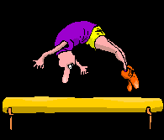





To Join the **Salto lottery** fill in the form below and enclose a cheque or cash for £1.00 a month for

each number. (i.e 12.00 per number for the whole year)

***See the Lottery notice board near the asymmetric bars***

Please make cheques payable to **SALTO** and write **‘Salto Lottery** on the reverse. **Return with cheque in a sealed envelope clearly marked Lottery, FAO Angie Grainger** and hand in to coach, to be placed in the Lottery tray in reception.

A number will be issued and given to the gymnast/ club member, or if you give me your email address I will email it to you.

The draws are usually the 1stSaturday of each month. Results will be displayed on the Lottery Notice Board.

**Thank you for supporting us, and good luck!**

……………………………………………………………………………………………………………………………………………………………………………………

I wish to join the **SALTO Lottery**. (**1st Jan 2010 - 31st Dec 2010)**

I enclose £1.00 per number, per ………… months. Total £…………

NAME …………………………… CHILD’S NAME…………………………………………

Your coach’s name and day/time of class …………………………………………

………………………………………………………………………………………………………………………

ADDRESS……………………………………………………………………………………………………

POST CODE …………………………………… TEL. No. ……………………………………….

Email ………………………………………………………………………………………………

**Bedfordshire County Floor & Vault From a General Gym Perspective**









Bedfordshire County Floor & Vault has been long renowned to be the Longest Competetion in the world. And this year brought about no disappointment. With 70 entries just from Salto alone it was always destined to be a long one. The good news is that at County Level it has been agreed that next year the event will be split over 2 separate days for the General levels and the Artistic Levels.

For our youngest competitors and what was probably the largest group Salto took the first 5 places. Top scorers and gold medals went jointly to Jemma Doherty and Annabel Cook. Kira Green took the Bronze and Grace Beeston came 4th.

The next group also took the 3 medals with Ferial Siad in 1st with Jazz Sears and Grace Alcock taking Joint Bronze.

Recreational Gymnast Lauren Alderson did really well and achieved a silver medal.

The general level 2 under 11’s proved to be a tougher contest. With over 20 gymnasts in this level and age group places were spread over the field. Highest medal position went to Alice Frost who took silver. In the 12 + Charlotte Mitchell also took a silver medal. Not wishing to break the trend the over 13 saw Nicloa Sheehan take the silver medal.

Turning to the Boys Gold medal went to Keon Mcgivney. Silver medals went To Charlie Nelson, Alex Mithcell and Nishant Chavda all in their relevant age groups. And bronze medal went to William Walford.

All the medals won were for overall positions. For individual apparatus please see the completion page on our web site.

Salto is definitely gaining confidence in their competition. Now so many of our gymnasts our taking part in these events it will help to progress steadily in their gymnastic careers. With paths already set for next year’s performance.

Helen Matthew

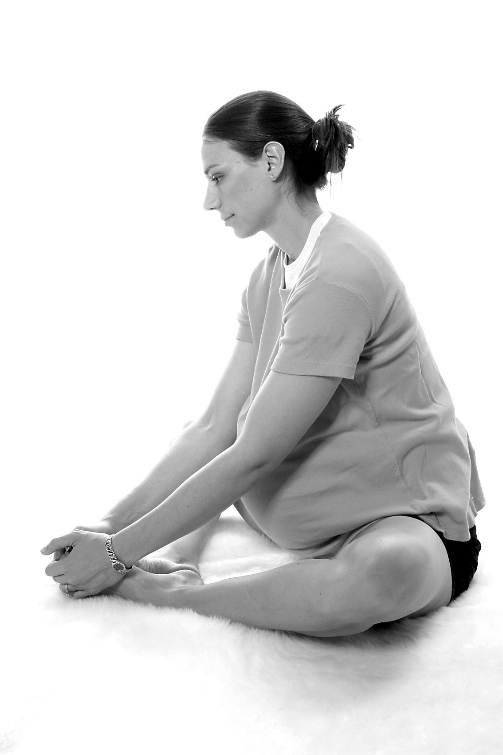Relax, Stretch &  
Breathe -

Yoga based exercise

for Pregnancy

& Birth

Suitable for all stages of pregnancy

Saturdays 2:45 – 4:45pm at SALTO

Courses cost £66 for 6 weeks

Please contact us to find out the dates of the next course and to book on [bookings5L@nct.org.uk](mailto:bookings5L@nct.org.uk) 0844 243 6891

 Registered Office: Alexandra House, Oldham Terrace, London W3 6NH Web-site: www.nct.org.uk  
Office and Admin: 0870 770 3236 Breastfeeding Line: 0870 444 8708   Pregnancy and Birth Line: 0870 444 8709   
Registered Charity Number: 801395    Registered Company number: 2370573 (England)  
The NCT wants all parents to have an experience of pregnancy, birth and early parenthood that enriches their lives and gives them confidence in being a parent.

**Acrobatic Gymnastics**









This was our first competition since the Regional Championships in February and it gave us a chance to try out all our new pairs and groups. Very successfully as it turned out. Everyone performed really well, all the balances were held, the routines looked polished and we won some medals.

In the Prep B Competition Mollie Skelton and Daisy Dando finished 5th with Melissa Clark and Emilia Corvesor close behind in 6th and Sadie Marwaha and Tayla Copley in 10th. Melissa and Sadie partnered up with Annya Corvesor in the Novice Trio Competition and finished 6th.

The Grade 1 Pairs was the largest group of the day with 18 entries and in the end only 2 marks separated 2nd and 18th a very very close competition. Gemma Parr-Smith and Brooke McCarthur won the silver medal scoring respectable 22.85. Our other pairs were Hayley Jesson and Emily Salton and Charlotte Dodd and Niamh Taylor scoring 21.55 and 21.40 respectively.

Tamar Robinson, Georgia Lockett and Lizzie Hobbs competing together for the first time performed beautifully scoring the highest mark of any pair or group during the day. They led the Grade 1 Trio Competition from start to finish and won the gold medal by a whole mark. Joanna Matthews, Abby Frazer and Ebonee Roberts-Edema also competing for the first time together scored 22.95 to finish 5th in the group of 15 trios.

In the Grade 2 Pair Competition another new pair Claire Mortimer and Angel Smith competed against 6 other pairs and won the silver medal. There were 4 groups competing in the Grade 2 Competition and Salto finished 1st and 2nd. Laura Hennessy, Rebecca Coulthard and Abbie Lampard won the gold and Abi Waller, Hannah Deacon and Faye Leek the silver.

All in all it was a very successful day. Thanks to all the parents who gave up their Sunday to help, the competition could not go ahead without you. Also thanks to my fellow coaches Carol, Graham and Steve for all their hard work getting the routines ready.

Spellbound eat your heart out!

Jean Large

High Performance Coach Acrobatic Gymnastics.

**Tumbling Report**

Our gymnasts made club history with **Joanna Matthews** and **Elliott Browne** winning 2 British tumbling titles on consecutive weekends in May.









In the British Schools Championships, Elliott representing Lea Manor High School led from his first tumble. Holding his nerve throughout he never look like relinquishing his lead and with some solid landings managed to clinch the Under 13 Boy’s title.

Icknield High School’s Joanna looked in great form in her warm ups and with scores of 9.35, 9.00 and 9.2, was never in any trouble and was over a whole mark clear of her nearest rival in winning the Girl’s Under 13 championships. **Hayley Jesson** (Lealands) tumbled consistently to finish in 14th place.

The standard in the Over 13 Girls competition was very high and **Farah Erahdun** (Luton 6th Form College) and **Samantha Jesson** (Lealands) found themselves up against gymnasts from the British silver medal winning team from the European Championships. Whilst never in contention for a medal, both tumbled well and finished in the top ten.

In the Under 11 events, Salto’s other competitors, **Megan McLaughlin** (Pirton Hill Primary) and **Alex Mitchell** both competing nationally for the first time had top ten finishes in their respective events, whilst **Nishant Chavda** (Ashcroft High) tumbled well in the Boy’s Over 13 event.

However, it was to be in the British NDP Championships that our gymnasts were to give their finest ever tumbling performance.

In the Elite 3 Women’s tumbling 13/14 years, Joanna was up against **Georgia Downing**. After 2 tumbles Joanna was just in first place by virtue of a magnificent first tumble. Going into the third and final tumble which concluded with a double twisting back somersault, both gymnasts knew that a stumble or a fall could relegate either of them out of the medals to last place. Tumbling in reverse order, Georgia went second to last and with an excellent somersault really applied the pressure. However, Joanna’s nerve held and despite a small step on landing, comfortably became British Champion with Georgia runner up.

The tension continued in the Elite 3 Men’s Championship. Having moved up a level and an age group from last year Elliott was in first place going into his last tumble but by just 0.20 of a mark. The many hours spent in the gym paid off when, really under pressure, he performed the highest scoring final tumble of the competition to win a gold medal for the second year running.









Not to be outdone, **Nishant Chavda** was inspired to a silver medal in only his second national final, coming second in the Over 13 National 1 Men’s tumbling. With **Jenny Grainger** coming agonisingly close to a medal in the Over 13 Women’s National 3 Final, finishing in fourth place and **Eavion Richardson**, also competing in a national final for the first time, finishing fifth in the National 2 Women’s 11-12 competition, it proved to be a satisfying weekend for our gymnasts.

Eric Phillips

|  |  |  |
| --- | --- | --- |
| Contact | Issue | Email |
| Helen Matthews | Issues related to Artistic Gymnastics | artistic@saltogym.plus.com |
| Mark Jesson | Astar leotards orders and enquires | astarleotards@saltogym.plus.com |
| Amanda Browne | External Hire and Costs | Bookings@saltogym.plus.com |
| Mark Jesson | Volunteers, Ideas,Events | Fundraising@saltogym.plus.com |
| Carl Richardson | Non specfic club enquiries | [info@saltogym.plus.com](mailto:info@saltogym.plus.com) |
| Carl Richardson | Club administration or comments | Managementcommit-tee’saltogym.plus.com |
| Helen Matthews | New and Existing non-salto Youth Fitness Membership Enquiries | [membership@saltogym.plus.com](mailto:membership@saltogym.plus.com) |
| Amanda Browne | Party External Hire and Costs | [parties@saltogym.plus.com](mailto:parties@saltogym.plus.com) |
| Jean Large | Issues related to Acrobatic Gym-nastics | [sportsacro@saltogym.plus.com](mailto:sportsacro@saltogym.plus.com) |
| Amanda Browne | Issues related to Subs and payments | [subscriptions@saltogym.plus.com](mailto:subscriptions@saltogym.plus.com) |
| Mark Jesson | For the zone orders and enquiries | [thezone@saltogym.plus.com](mailto:thezone@saltogym.plus.com) |
| Carl Richardson | Charity related matters | [trustees@saltogym.plus.com](mailto:trustees@saltogym.plus.com) |
| Adam Downing | Contributions or suggestions regarding website | [webfeedback@saltogym.plus.com](mailto:webfeedback@saltogym.plus.com) |
| Noreen Wolfe | Child welfare and protection including CRB Checks | welfare@saltogym.plus.com |

**Salto Summer School**

Childs Name: _____________________________ D.O.B: ___________________ Age: ____

Parents Name: ____________________________

Home Tel Number: ________________________

Work Tel Number: _________________________

Mobile Number: ___________________________

Email Address: ____________________________

Contact Name: ____________________________

(In case of emergency if different from above)

Tel Number: ______________________________ Alternative Number: ______________________

**If the child suffers from any allergies or medical incapacities, Please give details below.**

______________________________________________________________________________________________________________________________________________________

**Is there anything else we should know?**

___________________________________________________________________________

I give consent for my child to attend the following Salto Summer School 2009 Sessions and give my consent for staff to administer first aid to my child should the need arise.

(Please circle the correct time or Full day)

Prices are Non members/members respectively.

£9.00/£8.00 £9.00/£8.00 £16.00/£14.00

Wednesday 28th July 9:30 – 12:30 13:30 – 16:30 Full Day £

Thursday 29th July 9:30 – 12:30 13:30 – 16:30 Full Day £

Wednesday 4th August 9:30 – 12:30 13:30 – 16:30 Full Day £

Thursday 5th August 9:30 – 12:30 13:30 – 16:30 Full Day £

Wednesday 11th August 9:30 – 12:30 13:30 – 16:30 Full Day £

Thursday 12th August 9:30 – 12:30 13:30 – 16:30 Full Day £

Wednesday 18th August 9:30 – 12:30 13:30 – 16:30 Full Day £

Thursday 19th August 9:30 – 12:30 13:30 – 16:30 Full Day £

Wednesday 25th August 9:30 – 12:30 13:30 – 16:30 Full Day £

Thursday 26th August 9:30 – 12:30 13:30 – 16:30 Full Day £

I enclose full payment of £ ______________

Parent / Guardian signature: ___________________________ Date: __________________

Paid CASH / CHEQUE Signed: _______________________